CHAPTER THREE
RESEARCH METHODOLOGY

3.1 Introduction
This chapter presents the methodology for developing the Artificial Intelligence-based predictive policing model described in Chapter One. Each of the four objectives in Section 1.3 corresponds to a stage of the method. Objective (i), the collection of data from Zone 17 Headquarters, is covered in Sections 3.3 and 3.4. Objective (ii), the crime-data enrichment process, is covered in Section 3.5. Objective (iii), the hybrid spatial-temporal prediction model with its integrated explainability, is covered in Sections 3.6 to 3.8, and Objective (iv), the evaluation against baseline models, is covered in Sections 3.9 and 3.10.
Chapter Two explained what graph attention networks, gated recurrent units, Transformers, explainable AI methods and the performance metrics are, and why they were chosen. This chapter does not repeat those explanations. It states the design decisions and the full equations of each component, and it refers back to Chapter Two for the underlying concepts. The equations are numbered 3.1 to 3.52, and a flowchart is given for each major stage. Where a component was specified in the design but not used in the experiments reported in Chapter Four, the text says so.

3.2 Research Design and Methodological Framework
The study follows an experimental, quantitative and design-engineering approach. A predictive artefact, the hybrid model, is designed, implemented and evaluated on historical crime records. The method is a sequential pipeline in which the output of each stage is the input to the next, with an evaluation feedback loop that allows the hyper-parameters to be tuned again until the performance is satisfactory. Figure 3.1 summarises the workflow.
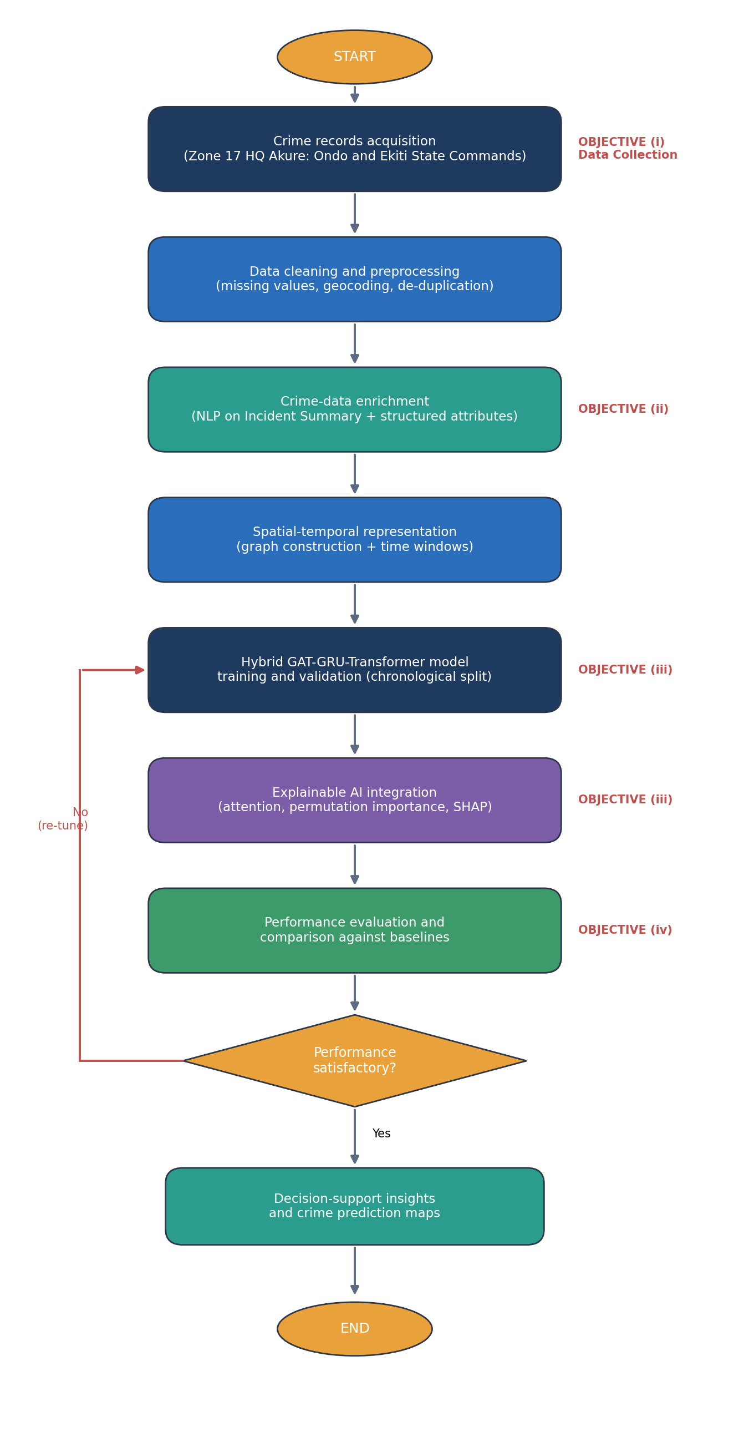
Figure 3.1: Overall methodological framework of the proposed AI-based predictive policing model.
The pipeline begins with the collection of crime records from Zone 17 Headquarters (Objective i). It continues with cleaning and preprocessing, crime-data enrichment (Objective ii), spatial-temporal representation, construction, training and validation of the hybrid model together with its explainability analysis (Objective iii), and comparative evaluation (Objective iv). The final outputs are interpretable decision-support products, namely crime-prediction maps and ranked risk factors, which is consistent with the decision-support scope stated in Section 1.5.

3.3 Study Area and Data Source
The research is limited to the jurisdiction of Zone 17 Headquarters, Akure, of the Nigeria Police Force. Zone 17 comprises the Ondo State Command and the Ekiti State Command in south-western Nigeria. The records cover divisions across Akure, Owo, Ondo, Ikare and their surroundings in Ondo State, and Ado, Ikere, Ikole and their surroundings in Ekiti State. The zone offers a sample of both urban and semi-urban crime conditions in a data-sparse operational environment of the kind found in many African policing contexts (Section 2.6.4). The records cover January 2022 to December 2025 and are analysed for their spatial and temporal characteristics. The limits of the study (no surveillance hardware and no operational deployment) are those given in Section 1.5.

3.4 Data Collection and Dataset Description
The first objective was met by collecting the crime records from Zone 17 Headquarters, Akure, for the Ondo and Ekiti State Commands. The dataset has approximately 29,000 incident records. Each record has structured fields, which are categorical, numerical, spatial and temporal attributes held in fixed columns, and a semi-structured free-text Incident Summary that describes the incident. Table 3.1 lists the principal fields and the role of each in the model. The profile of the dataset, including its data-quality problems, is reported in Section 4.2, and the way these problems are handled is described in Section 3.5.1.
Table 3.1: Description of the principal fields in the Zone 17 crime dataset
Field | Type | Description | Role in model
Incident ID | Identifier | Unique record reference | Indexing and de-duplication
Date and time of occurrence | Temporal | Date and time the incident occurred | Temporal features and sequencing
Reporting time | Temporal | Date and time the incident was reported | Reporting-delay feature
Zone, State Command, Area Command | Categorical | Administrative zone and command under which the incident was recorded | Spatial hierarchy and jurisdiction mapping
Reporting division or outpost | Categorical | Police division, outpost, town or area | Spatial node assignment
Latitude, longitude | Numeric | Geo-coordinates of the incident | Graph construction
Offence type | Categorical | Crime category (for example theft, assault, burglary) | Target and structured feature
Sub-category | Categorical | Specific classification of the offence | Fine-grained target and structured feature
Severity | Categorical | Severity level of the incident (high, medium or low) | Structured feature
Incident Summary | Free text | Narrative account of the incident | NLP enrichment source
Modus operandi or weapon used | Categorical | Method by which the offence was carried out | Behavioural feature and pattern recognition
Action or status | Categorical | Case status or resolution | Auxiliary feature

3.5 Crime-Data Enrichment Process
The second objective is met by an enrichment process that turns the free-text Incident Summary into machine-readable features and fuses them with the structured attributes. It applies the narrative-analysis approaches reviewed in Section 2.7.2 and 2.11.7 to the Nigerian records. The process is shown in Figure 3.2. NLP is used for enrichment only, and it is separate from the prediction task.
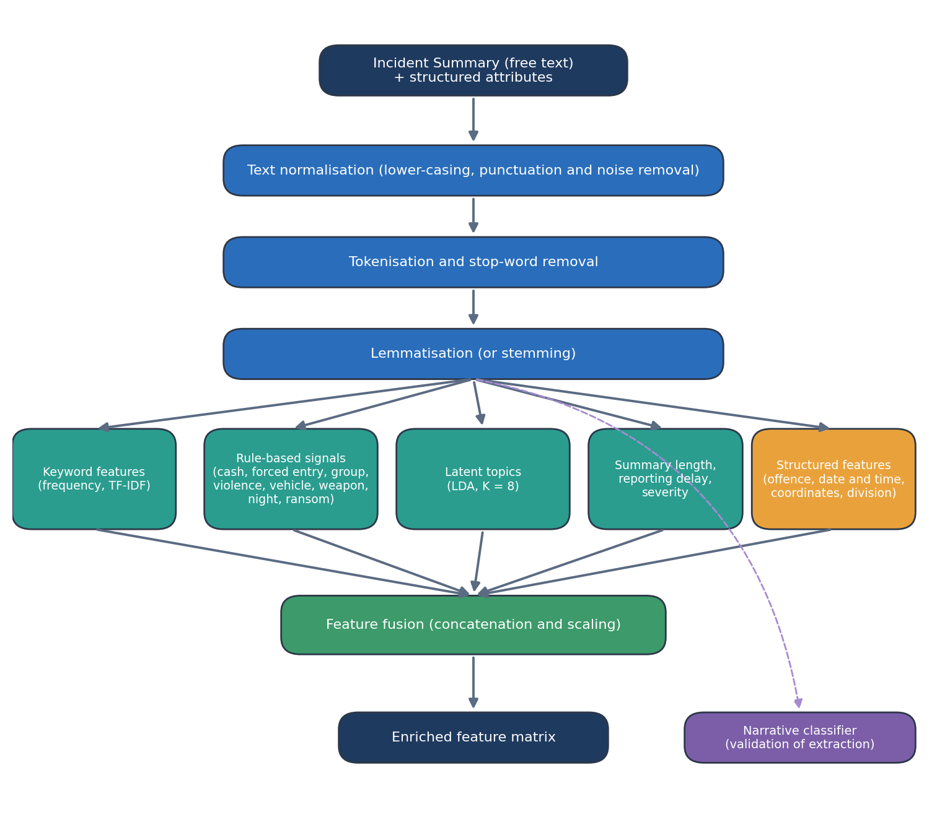
Figure 3.2: Crime-data enrichment (NLP) pipeline that converts the Incident Summary into fused features.

3.5.1 Data Cleaning and Preprocessing
The raw records are cleaned before enrichment. Duplicate records are removed, inconsistent category labels are harmonised, date and time formats are standardised, and missing values are imputed or the records excluded. Records with irrecoverably missing spatial or temporal information are flagged. Where coordinates are absent but a textual location is available, the location is geocoded to a latitude and longitude pair. These steps address the incompleteness and inconsistency problems described in Section 2.7.5. Numeric attributes are then scaled and categorical attributes are encoded as described in Section 3.5.4.

3.5.2 Text Preprocessing of the Incident Summary
Each narrative is normalised by lower-casing it and removing punctuation, digits that act as noise and extra whitespace. It is then split into tokens, and stop-words that carry little discriminating value are removed. The remaining tokens are reduced to their base forms by lemmatisation (or stemming, as shown in Figure 3.2). The result for each incident is a clean set of informative tokens that is passed to feature extraction.

3.5.3 Feature Extraction from Text
Five groups of features are extracted from the cleaned narratives and the structured attributes.
Keyword features. The Term Frequency–Inverse Document Frequency (TF-IDF) scheme (Sparck Jones, 1972) measures the importance of each term relative to the corpus, and the most frequent terms give the keyword features. The term frequency of term $t$ in document (incident narrative) $d$ is
 | tft,d=ft,dt'∈d​ft',d | (3.1)

where $f_{t,d}$ is the number of times $t$ occurs in $d$. The inverse document frequency down-weights terms that occur in many narratives:
 | $$idf\left(t\right)=log\left(\frac{N}{1+\left|\{d∈D:t∈d\}\right|}\right)$$ | (3.2)

where $N$ is the number of narratives and $D$ is the corpus. The TF-IDF weight of a term is the product of the two:
 | $$w_{t,d}=tf\left(t,d\right)×idf\left(t\right)$$ | (3.3)

Rule-based modus-operandi signals. Binary indicators are derived by pattern matching for mentions of cash, forced entry, group involvement, violence, vehicles, weapons, night-time and ransom in the narrative. The indicators are easy to read and explain (Section 2.9), but they are sparse, since each applies to only a small share of incidents.
Latent themes. Latent Dirichlet Allocation (LDA) (Blei et al., 2003) is a probabilistic topic model in which the probability of a word given a document is a mixture over $K$ latent topics. Eight topics are used, and the topic proportions of each incident become features:
 | $$p\left(w∣d\right)=\sum_{z=1}^{K}{p}\left(w∣z\right) p\left(z∣d\right)$$ | (3.6)

Narrative length, reporting delay and severity. The length of the summary and the reporting delay, which is the number of hours between the time of occurrence and the time of reporting, are derived for each incident. Severity is taken from the structured field and cleaned. These three fields were cleaned, engineered or derived during enrichment.
Narrative classifier. A supervised text classifier is trained to predict the crime category from the narrative. It is not part of the prediction model. Its purpose is to test how much information the narratives carry and to measure the label noise in the records (Section 4.3).
Semantic embeddings (extension). To capture similarity that exact word matching misses, distributed word embeddings such as Word2Vec (Mikolov et al., 2013) or FastText (Bojanowski et al., 2017) can be used. Each token $w$ is mapped to a $k$-dimensional vector $v_{w}$, and the document embedding is the mean of its token vectors:
 | $$e_{d}=\frac{1}{\left|d\right|}\sum_{i=1}^{\left|d\right|}{v_{w_{i}}}, v_{w_{i}}∈R^{k}$$ | (3.4)

The similarity of two narratives, used to cluster and de-duplicate near-identical reports, is the cosine similarity of their embeddings:
 | $$sim\left(a,b\right)=\frac{a⋅b}{∥a∥ ∥b∥}$$ | (3.5)

Embeddings are specified here as an extension. The experiments in Chapter Four use the keyword, rule-based, topic, length and delay features described above.

3.5.4 Structured Feature Engineering
The structured attributes are engineered in parallel into a numeric feature block. Categorical fields such as offence type, division and outcome are one-hot or target encoded. Cyclical time features (hour of day, day of week and month) are sine–cosine encoded so that their periodic nature is preserved (Section 2.7.3), and spatial coordinates are kept for graph construction. All numeric features are standardised to zero mean and unit variance to stabilise learning. No feature is built from information from the period to be predicted, in order to avoid data leakage (Section 2.7.3).

3.5.5 Feature Fusion
The enriched representation of each incident, or of each spatial-temporal cell after aggregation, is formed by early fusion (Section 2.7.3). The structured feature block $s$, the text embedding and TF-IDF block $e$ and the topic and entity block $t$ are concatenated into one vector:
 | $$x_{i}=\left[s_{i} ∥ e_{i} ∥ t_{i}\right]∈R^{F}$$ | (3.7)

where $F$ is the total number of features. The fused vectors make up the input feature matrix used by the prediction model.

3.6 Spatial-Temporal Data Representation
To model crime over both space and time, the enriched incidents are aggregated into a spatial-temporal structure, with space as a graph of crime locations and time as a sequence of discrete intervals (Section 2.6.2). The graph lets the model learn how crime in one location relates to crime in neighbouring locations, and the sequence lets it learn how crime develops over successive periods. The incidents are aggregated into time windows of 3days, 1 week and 1month.

3.6.1 Spatial Graph Construction
The study area is divided into $N$ spatial units, and each unit is a node. In this study the nodes are the police divisions and outposts of Zone 17 in the Ondo and Ekiti State Commands. The nodes, edges and weighted adjacency matrix define the graph:
 | $$G=\left(V,E,A\right), \left|V\right|=N$$ | (3.8)

The distance between the centroids of two nodes is computed with the Haversine formula (Sinnott, 1984):
 | $$d_{ij}=2Rarcsin\sqrt{\sin^{2}\frac{Δϕ}{2}+cosϕ_{i}cosϕ_{j}\sin^{2}\frac{Δλ}{2}}$$ | (3.9)

where $ϕ$ and $λ$ are latitude and longitude, $Δϕ$ and $Δλ$ are their differences between the two nodes, and $R$ is the radius of the Earth. Edge weights come from a Gaussian (radial-basis) kernel of the distance with a cut-off, so that nearby locations are strongly connected and distant ones are not connected at all:
 | $$A_{ij}=\left\{\begin{matrix}exp\left(-\frac{d_{ij}^{2}}{2σ_{d}^{2}}\right) & \text{if }d_{ij}≤κ \\ 0 & \text{otherwise}\end{matrix}\right.$$ | (3.10)

where $σ_{d}$ is the bandwidth and $κ$ is the distance threshold. The graph defines the neighbourhood $N_{i}$ of each node used by the GAT. For the graph convolution baselines (Section 3.9), the adjacency matrix is given self-loops and normalised symmetrically (Kipf and Welling, 2017):
 | $$\hat{A}=D^{-\frac{1}{2}}\left(A+I\right)D^{-\frac{1}{2}}$$ | (3.11)

where $I$ is the identity matrix and $D$ is the diagonal degree matrix of $A+I$. This keeps the scale of the aggregated features similar across nodes with different numbers of connections.

3.6.2 Node Feature Matrix and Temporal Tensor
Each node carries the fused feature vector from Section 3.5, and the node feature matrix stacks the vectors of all $N$ nodes:
 | $$X={\left[x_{1},x_{2},…,x_{N}\right]}^{⊤}∈R^{N×F}$$ | (3.12)

Because crime counts and characteristics change over time, the node features are recorded for $T$ successive intervals. This gives the three-dimensional spatial-temporal tensor introduced in Section 2.6.2:
 | $$X∈R^{T×N×F}$$ | (3.13)

The tensor and the adjacency matrix together are the complete input to the hybrid model.

3.7 Hybrid GAT-GRU-Transformer Prediction Model (Objective iii)
The first part of the third objective is met by a hybrid architecture in which each of the three mechanisms has a separate task, as proposed in Section 2.10 and in the research gap of Section 2.12. A Graph Attention Network (GAT) learns spatial dependence by attending to the most relevant neighbouring locations. A Gated Recurrent Unit (GRU) captures short-range temporal change across consecutive intervals. A Transformer encoder models long-range temporal dependence through self-attention. The three representations are fused and passed to a prediction head. Figure 3.3 shows the architecture.
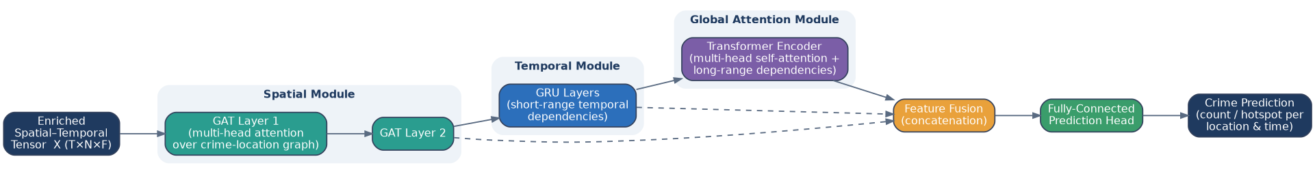
Figure 3.3: Architecture of the proposed hybrid GAT-GRU-Transformer crime prediction model.

3.7.1 Spatial Learning with the Graph Attention Network
The GAT layer updates each node by aggregating its neighbours with learnable attention weights, so that the most informative neighbours count for more (Veličković et al., 2018). In the first layer the node representation $h_{i}$ is the fused feature vector $x_{i}$ of the node at the given time step. For two connected nodes $i$ and $j$, an un-normalised attention score is computed from their transformed features:
 | $$e_{ij}=LeakyReLU\left(a^{⊤}\left[Wh_{i} ∥ Wh_{j}\right]\right)$$ | (3.14)

where $W$ is a shared weight matrix, $a$ is a learnable attention vector and $∥$ denotes concatenation. The scores over the neighbourhood $N_{i}$ are normalised with a softmax to give the attention coefficients:
 | αij=softmaxjeij=expeijk∈Ni​expeik | (3.15)

The updated representation is the attention-weighted sum of the transformed neighbour features, passed through a non-linearity $σ$:
 | hi'=σj∈Ni​αij Whj | (3.16)

To stabilise learning and capture several relational patterns, $M$ independent attention heads are used. In the intermediate layers their outputs are concatenated:
 | hi'=‖m=1M σj∈Ni​αijm Wmhj | (3.17)

In the final layer the heads are averaged, which gives the spatial embedding of each node at each time step:
 | hi'=σ1Mm=1Mj∈Ni​αijm Wmhj | (3.18)

3.7.2 Short-Range Temporal Learning with the Gated Recurrent Unit
The sequence of spatial embeddings over the $T$ intervals is passed through a GRU (Cho et al., 2014), whose gates regulate the flow of information (Section 2.3.2). The update gate decides how much of the previous state is kept:
 | $$z_{t}=σ\left(W_{z}x_{t}+U_{z}h_{t-1}+b_{z}\right)$$ | (3.19)

The reset gate decides how much past information is discarded when the candidate state is formed:
 | $$r_{t}=σ\left(W_{r}x_{t}+U_{r}h_{t-1}+b_{r}\right)$$ | (3.20)

The candidate hidden state combines the current input with the gated previous state, where $⊙$ is element-wise multiplication:
 | $${\tilde{h}}_{t}=tanh\left(W_{h}x_{t}+U_{h}\left(r_{t}⊙h_{t-1}\right)+b_{h}\right)$$ | (3.21)

The new hidden state is an interpolation between the previous state and the candidate, controlled by the update gate:
 | $$h_{t}=\left(1-z_{t}\right)⊙h_{t-1}+z_{t}⊙{\tilde{h}}_{t}$$ | (3.22)

Here $x_{t}$ is the spatial embedding of the node at interval $t$, and $W$, $U$ and $b$ are trainable weight matrices and bias vectors. The GRU gives a representation of each location that is aware of its recent history.

3.7.3 Long-Range Dependency Learning with the Transformer
A Transformer encoder with multi-head self-attention (Vaswani et al., 2017) is applied to the GRU output sequence, to capture the long-range patterns that the recurrent state may weaken (Section 2.3.3). Sinusoidal positional encodings are first added to give each interval a position, for even and odd dimensions:
 | $$PE_{\left(p,2i\right)}=sin\left(\frac{p}{{10000}^{2i/d_{model}}}\right)$$ | (3.23)

 | $$PE_{\left(p,2i+1\right)}=cos\left(\frac{p}{{10000}^{2i/d_{model}}}\right)$$ | (3.24)

where $p$ is the position in the sequence, $i$ is the dimension index and $d_{model}$ is the model dimension. The position-augmented representation $H$ is projected into query, key and value matrices through learned weights:
 | $$Q=HW^{Q}, K=HW^{K}, V=HW^{V}$$ | (3.25)

Scaled dot-product attention then combines the values according to the compatibility of queries and keys:
 | $$Attention\left(Q,K,V\right)=softmax\left(\frac{QK^{⊤}}{\sqrt{d_{k}}}\right)V$$ | (3.26)

where $d_{k}$ is the key dimension used for scaling. Several attention heads are computed in parallel, each as
 | $${head}_{i}=Attention\left(Q_{i},K_{i},V_{i}\right)$$ | (3.27)

and their outputs are concatenated and linearly projected:
 | $$MHA\left(H\right)=\left[{head}_{1} ∥⋯∥ {head}_{h}\right]W^{O}$$ | (3.28)

Each encoder block also has a position-wise feed-forward network:
 | $$FFN\left(x\right)=ReLU\left(xW_{1}+b_{1}\right)W_{2}+b_{2}$$ | (3.29)

Residual connections and layer normalisation (Ba et al., 2016) surround both the attention and the feed-forward sub-layers. For the attention sub-layer,
 | $$Z=LayerNorm\left(H+MHA\left(H\right)\right)$$ | (3.30)

where layer normalisation is
 | $$LayerNorm\left(x\right)=γ⊙\frac{x-μ}{\sqrt{σ_{x}^{2}+ϵ}}+β$$ | (3.31)

with mean $μ$ and variance $σ_{x}^{2}$ taken over the features of the input, a small constant $ϵ$, and learnable scale $γ$ and shift $β$. The same pattern is applied around the feed-forward network.

3.7.4 Feature Fusion and Prediction
The three modules work in sequence. The GAT produces the spatial representation:
 | $$H^{S}=GAT\left(X,A\right)$$ | (3.32)

which is passed through the GRU to give a short-range temporal representation:
 | $$H^{R}=GRU\left(H_{1:T}^{S}\right)$$ | (3.33)

and the Transformer then refines this into a long-range attention representation:
 | $$H^{A}=Transformer\left(H^{R}\right)$$ | (3.34)

To keep the distinct contribution of each module, the three representations of a node at the end of the look-back window are concatenated into a joint feature vector:
 | $$u=\left[H^{S} ∥ H^{R} ∥ H^{A}\right]$$ | (3.35)

For the regression formulation, which predicts the crime count per location and interval, the fused vector is mapped to the output by a fully connected layer:
 | $$\hat{y}=W_{o}u+b_{o}$$ | (3.36)

For the hotspot-classification formulation, which predicts risk levels, a softmax output layer is used, with the class scores $o_{c}$ obtained from the same linear mapping:
 | $${\hat{y}}_{c}=\frac{exp\left(o_{c}\right)}{\sum_{c'=1}^{C}{exp}\left(o_{c'}\right)}$$ | (3.37)

where $C$ is the number of risk classes. In this study the task is binary ($C=2$): a cell, which is a division in a time window, is a hotspot when its incident count exceeds 0.

3.7.5 Loss Function and Optimisation
For regression, the model minimises the Smooth-L1 (Huber) loss (Huber, 1964), which is quadratic for small errors and linear for large errors and so is less affected by the rare extreme counts in sparse crime data (Section 2.5.2). An L2 weight decay term is added:
 | $$L_{reg}=\frac{1}{n}\sum_{i=1}^{n}{l}\left(y_{i}-{\hat{y}}_{i}\right)+λ∥Θ∥_{2}^{2}, l\left(e\right)=\left\{\begin{matrix}1/2e^{2} & \text{if }\left|e\right|<1 \\ \left|e\right|-1/2 & \text{otherwise}\end{matrix}\right.$$ | (3.38)

where $n$ is the number of training samples, $l$ is applied to the error $e=y_{i}-{\hat{y}}_{i}$, $Θ$ denotes the model parameters and $λ$ controls the L2 weight decay. For classification, the categorical cross-entropy is used:
 | $$L_{cls}=-\frac{1}{n}\sum_{i=1}^{n}{\sum_{c=1}^{C}{y_{i,c}}}log\left({\hat{y}}_{i,c}\right)$$ | (3.39)

The parameters are optimised with the Adam algorithm (Kingma and Ba, 2015), whose update uses bias-corrected first- and second-moment estimates ${\hat{m}}_{t}$ and ${\hat{v}}_{t}$ of the gradient:
 | $$Θ_{t+1}=Θ_{t}-η \frac{{\hat{m}}_{t}}{\sqrt{{\hat{v}}_{t}}+ϵ}$$ | (3.40)

where $η$ is the learning rate and $ϵ$ a small constant. Dropout (Srivastava et al., 2014), early stopping and gradient clipping are applied to limit over-fitting (Section 2.5.3), which is important because the records are sparse. Table 3.2 gives the principal hyper-parameters. The values are starting points that are tuned on the validation set.
Table 3.2: Principal hyper-parameters of the proposed hybrid model
Hyper-parameter | Symbol | Default (search range)
GAT hidden units | not applicable | 64 (32 to 128)
GAT attention heads | $$M$$ | 8 (4 to 16)
GRU hidden units | not applicable | 128 (64 to 256)
GRU layers | not applicable | 2 (1 to 3)
Transformer heads | $$h$$ | 8 (4 to 16)
Transformer encoder blocks | $$L$$ | 2 (1 to 4)
Model dimension | $$d_{model}$$ | 128
Dropout rate | not applicable | 0.3 (0.1 to 0.5)
Learning rate | $$η$$ | 1e-3 (1e-4 to 5e-3)
L2 weight decay | $$λ$$ | 1e-5
Batch size | not applicable | 32 (16 to 128)
Look-back window | $$T$$ | 12 intervals

3.8 Explainable Artificial Intelligence Integration
The second part of the third objective builds explainability into the model so that its predictions can be examined, which matters in policing because opaque outputs can weaken public trust and due process (Section 2.9). Three methods are used, and they are applied together (Figure 3.4). Attention weights from the GAT give an explanation that comes from inside the model. Permutation importance (Breiman, 2001) gives a model-agnostic ranking of the input features. SHAP gives a feature attribution computed on a surrogate model, because exact Shapley values are costly to compute for a deep network. LIME (Section 2.9) is not used, since SHAP already provides local and global attributions in one additive framework.
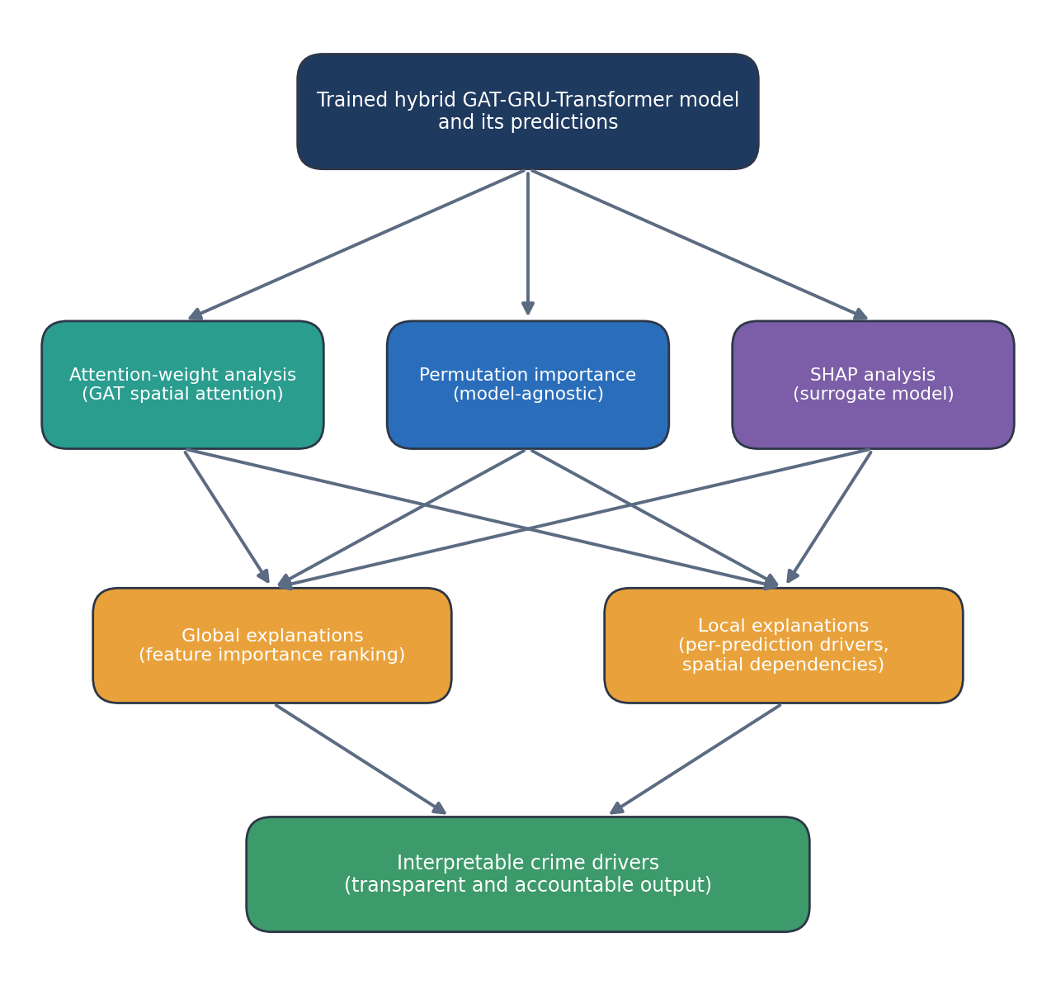
Figure 3.4: Explainable AI workflow producing global and local interpretations of the model.
Attention importance. The importance of a source location or time step $j$ for a target $i$ is the attention it receives, averaged over layers and heads:
 | $$Imp\left(j\right)=\frac{1}{Lh}\sum_{l=1}^{L}{\sum_{m=1}^{h}{α_{ij}^{\left(l,m\right)}}}$$ | (3.43)

High-importance neighbours and periods show which spatial and temporal factors the model relies on. Attention weights are not a definitive explanation (Wiegreffe and Pinter, 2019), so they are read together with the other two methods.
Permutation importance. The importance of feature $j$ is the increase in the prediction error when its values are randomly shuffled in the test data, $I_{j}=E_{j}^{perm}-E^{base}$, where $E$ is the error metric of the trained model.
SHAP. SHAP (Lundberg and Lee, 2017) attributes a prediction to the input features using cooperative game theory. The Shapley value of feature $i$ is its average marginal contribution over all coalitions of the other features:
 | ϕi=S⊆F∖{i}​S! F-S-1!F!fS∪{i}-fS | (3.41)

where $F$ is the full feature set, $S$ is a subset of features that excludes $i$ and $f$ is the prediction function of the model. SHAP writes any prediction as an additive model, so that a base value plus the feature contributions gives the output:
 | $$g\left(z'\right)=ϕ_{0}+\sum_{i=1}^{\left|F\right|}{ϕ_{i}} z_{i}'$$ | (3.42)

where $ϕ_{0}$ is the base value and $z_{i}'∈\{0,1\}$ shows whether feature $i$ is present. Averaging the magnitudes of the contributions across the dataset gives a global ranking of the factors behind the predictions, and the individual explanations show the local drivers of a single forecast. None of the three methods shows that a factor causes crime (Section 2.9).

3.9 Baseline Models and Experimental Design
To show what the proposed architecture adds, it is compared with six baseline models from classical statistics, machine learning and deep learning (Table 3.3). Each baseline is a reference point that the literature reviewed in Chapter Two used for crime prediction. All baselines are trained and tuned on the same data splits and evaluated with the same metrics as the proposed model.
The dataset is divided chronologically into training, validation and test sets, typically in the proportions 70%, 15% and 15%. The model is therefore always tested on later intervals that it has not seen, which reflects real use and prevents leakage of future information (Section 2.7.4). Figure 3.5 shows the comparison protocol.
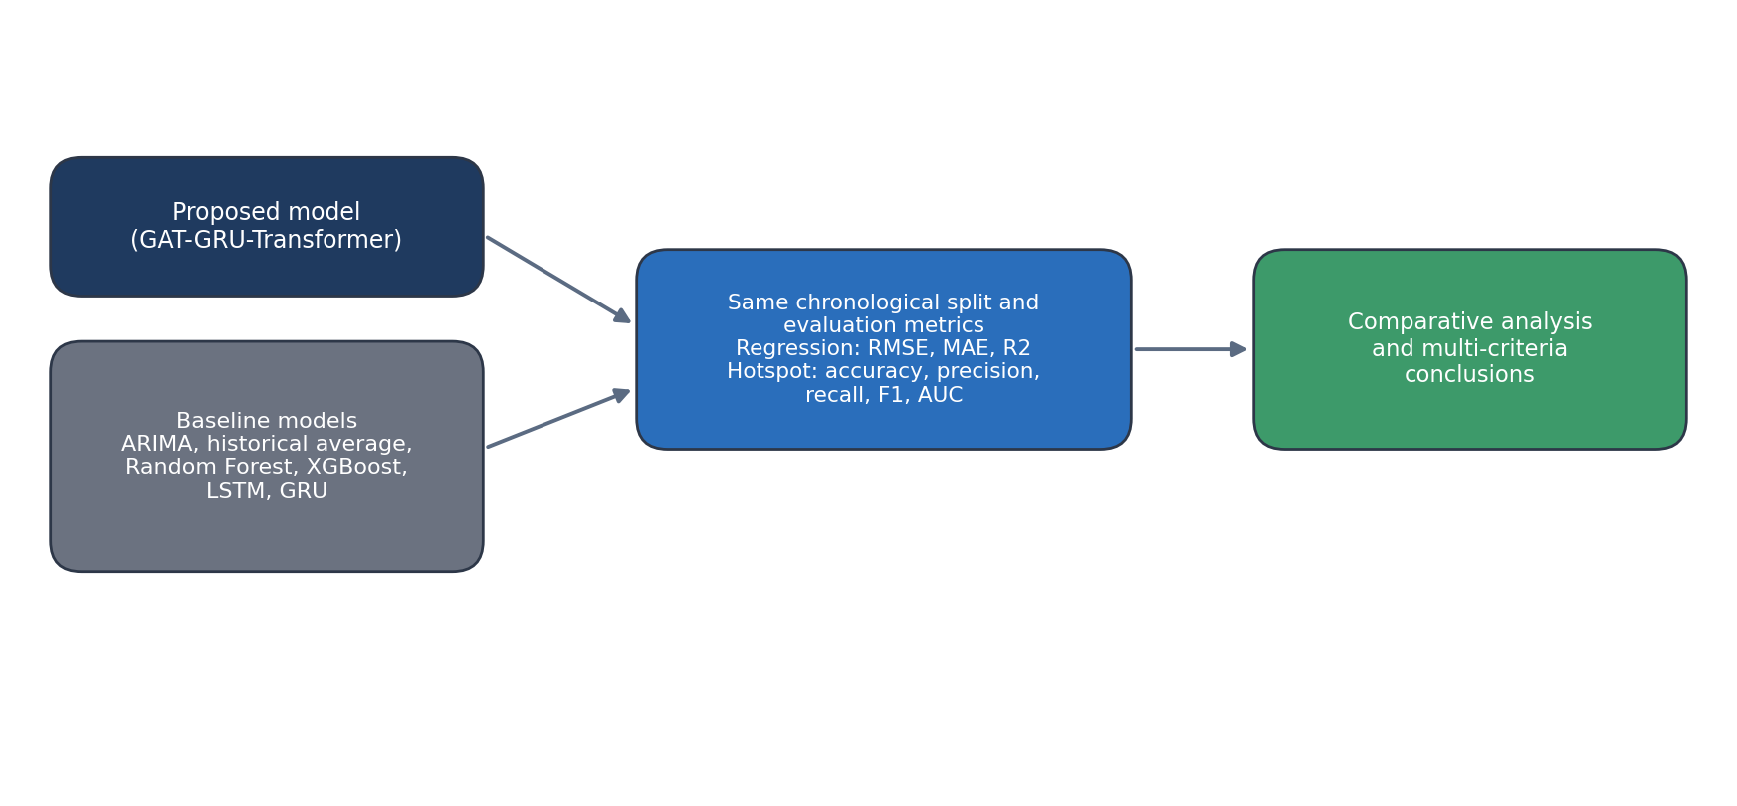
Figure 3.5: Comparative evaluation protocol against baseline models.
Table 3.3: Baseline models used for comparative evaluation
Baseline | Category | What it captures | Basis in the literature
ARIMA | Statistical time series | Linear temporal trends only | Adedamola and Ogundunmade (2025)
Historical average (persistence) | Naive benchmark | Recent level of crime, without learning | Common forecasting benchmark
Random Forest | Tree ensemble | Non-linear tabular relations | Breiman (2001)
XGBoost | Gradient-boosted trees | Non-linear tabular relations | G. Kim et al. (2025)
LSTM | Recurrent deep learning | Temporal dependencies | Hochreiter and Schmidhuber (1997); Devi and Kavitha (2021)
GRU (standalone) | Recurrent deep learning | Temporal dependencies, gated | Cho et al. (2014)

The graph-based baselines of the literature (GCN, standalone GAT and ST-GCN type models, Section 2.11.4) are not included in the experiments reported in Chapter Four, and their inclusion is suggested as further work (Section 5.5).

3.10 Performance Evaluation Metrics (Objective iv)
The fourth objective is met by evaluation with the metrics suited to the task formulation (Section 2.8). For the regression formulation, the Mean Absolute Error, Root Mean Squared Error, Mean Absolute Percentage Error and coefficient of determination are defined, where $y_{i}$ is the observed value, ${\hat{y}}_{i}$ the predicted value, $\overset{‾}{y}$ the mean observed value and $n$ the number of observations:
 | $$MAE=\frac{1}{n}\sum_{i=1}^{n}{\left|y_{i}-{\hat{y}}_{i}\right|}$$ | (3.44)

 | $$RMSE=\sqrt{\frac{1}{n}\sum_{i=1}^{n}{{\left(y_{i}-{\hat{y}}_{i}\right)}^{2}}}$$ | (3.45)

 | $$MAPE=\frac{100\%}{n}\sum_{i=1}^{n}{\left|\frac{y_{i}-{\hat{y}}_{i}}{y_{i}}\right|}$$ | (3.46)

 | $$R^{2}=1-\frac{\sum_{i=1}^{n}{{\left(y_{i}-{\hat{y}}_{i}\right)}^{2}}}{\sum_{i=1}^{n}{{\left(y_{i}-\overset{‾}{y}\right)}^{2}}}$$ | (3.47)

MAPE is undefined where the observed count is zero, which is common in the sparse counts of this dataset (Section 2.8), so Chapter Four reports RMSE, MAE and $R^{2}$ for count regression and does not report MAPE. For the hotspot-classification formulation, Accuracy, Precision, Recall, F1-score and the Area Under the ROC Curve (AUC) are used:
 | $$Accuracy=\frac{TP+TN}{TP+TN+FP+FN}$$ | (3.48)

 | $$Precision=\frac{TP}{TP+FP}$$ | (3.49)

 | $$Recall=\frac{TP}{TP+FN}$$ | (3.50)

 | $$F1=2⋅\frac{Precision⋅Recall}{Precision+Recall}$$ | (3.51)

 | $$AUC=\int_{0}^{1}{TPR}\left({FPR}^{-1}\left(x\right)\right)dx$$ | (3.52)

where TP, TN, FP and FN are the true positives, true negatives, false positives and false negatives, and TPR and FPR are the true-positive and false-positive rates. For multiclass crime-type prediction, the class-wise metrics are averaged by macro, weighted or micro averaging.
Each model is evaluated on the same chronological test split, and the metrics are reported as observed values for every model. Significance testing of the differences across repeated runs, with a paired $t$-test or the Wilcoxon signed-rank test (Section 2.8), was not carried out and is suggested as further work (Section 5.5).

3.11 Implementation Tools and Environment
The model and its pipeline are implemented in Python (Table 3.4). The deep learning components use PyTorch (Paszke et al., 2019) with PyTorch Geometric (Fey and Lenssen, 2019) for the graph layers, and explainability uses the SHAP library. The implementation runs directly on the uploaded data files. It detects the relevant columns by flexible name matching, infers their types, and adapts the enrichment and modelling pipeline to them.
Table 3.4: Software stack used in the implementation
Stage | Primary libraries
Data handling | pandas, numpy
NLP enrichment | nltk or spaCy, gensim, scikit-learn (TF-IDF)
Graph construction | networkx, scipy, torch-geometric
Deep learning | PyTorch, torch-geometric
Explainability | shap
Baseline models | scikit-learn (Random Forest), xgboost, PyTorch (LSTM, GRU)
Evaluation and plots | scikit-learn, matplotlib, seaborn

3.12 Analytical Plots Produced by the Implementation
For exploratory analysis, interpretation and reporting, the implementation generates the following plots from the data files:
- temporal crime trends, with daily, weekly and monthly incident counts and seasonal decomposition;
- crime distribution by offence type and by police division, as bar and pie charts;
- spatial hotspot maps and heatmaps of incident density across the study area;
- a correlation heatmap of the engineered structured and text features;
- a word cloud and top-term frequency plots from the Incident Summary field;
- LDA topic-distribution plots that summarise the latent themes in the narratives;
- training and validation loss and accuracy curves over the epochs;
- predicted-versus-actual scatter plots and residual plots for the regression task;
- a confusion matrix and ROC curves for the hotspot-classification task;
- SHAP summary and feature-importance plots for global explanation;
- attention-weight heatmaps for spatial and temporal interpretation; and
- comparative bar charts of all metrics for the proposed model against the baselines.

3.13 Chapter Summary
This chapter has set out the methodology for the proposed AI-based predictive policing model. It described the research design and pipeline (Figure 3.1) and the collection of the Zone 17 records for the Ondo and Ekiti State Commands (Objective i, Table 3.1). It then described the enrichment of the Incident Summary and its fusion with the structured attributes (Objective ii, Figure 3.2, Equations 3.1 to 3.7), the spatial-temporal representation and the hybrid GAT-GRU-Transformer architecture (Objective iii, Figure 3.3, Equations 3.8 to 3.40), the explainability layer (Objective iii, Figure 3.4, Equations 3.41 to 3.43) and the baselines, experimental protocol and metrics (Objective iv, Figure 3.5, Equations 3.44 to 3.52). Together these steps put the objectives of Chapter One into practice and apply the design reasoned out in the literature review of Chapter Two. The results of the experiments are presented in Chapter Four.
value.

